**APP activity 3: postgresql**

**Name:** Ann Johnnidis

Part 1) Creating tables

**UserOrder**

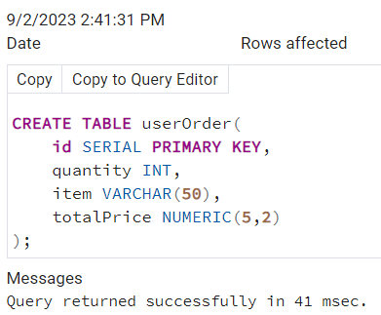

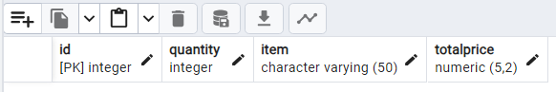

**userShippingAddress**

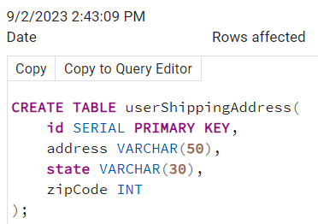

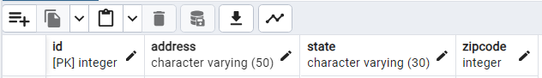

**userinfo**

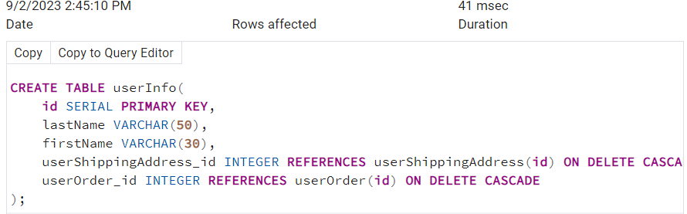

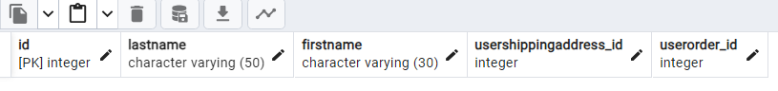

**userlogin**

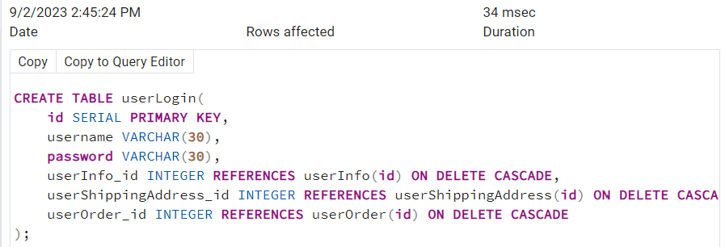

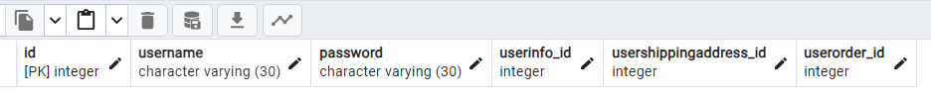

Part 2) Entering data in each table

**usershippingaddress**

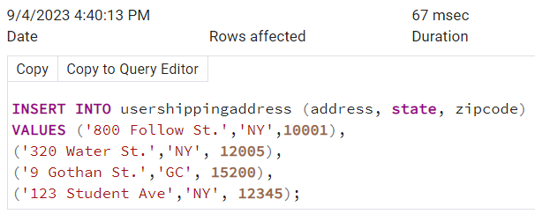

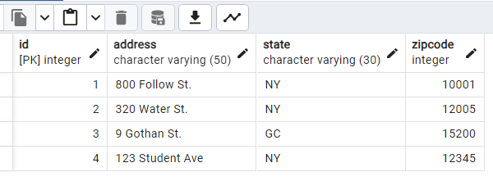

**Userorder**

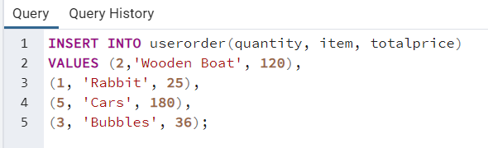

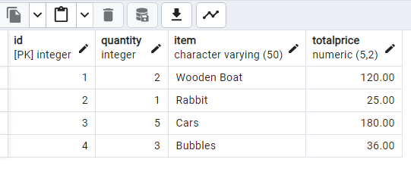

**Userinfo**

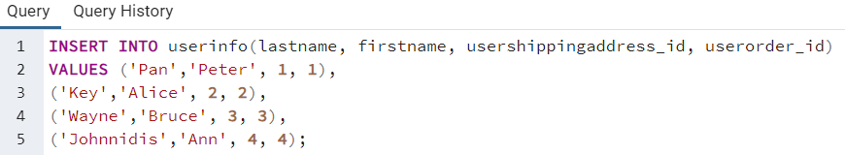

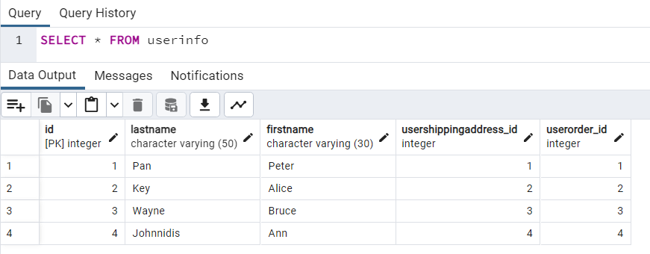

**Userlogin**

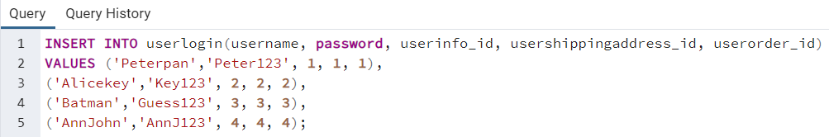

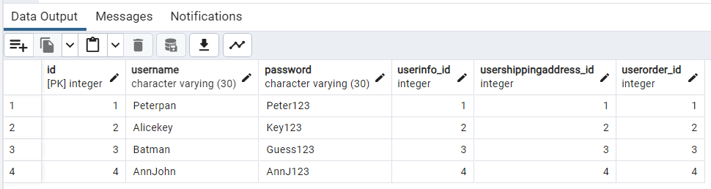

Part 3) Print data

**Username and totalprice**

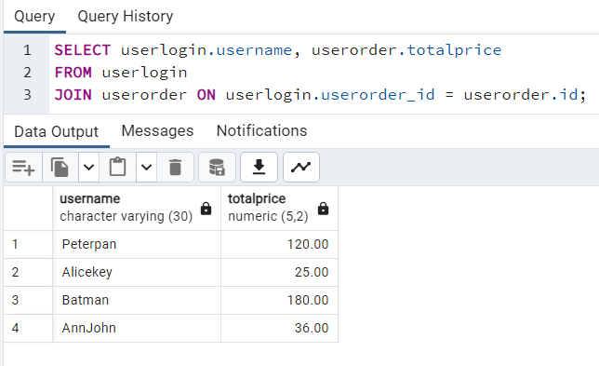

**Lastname, state, order items**

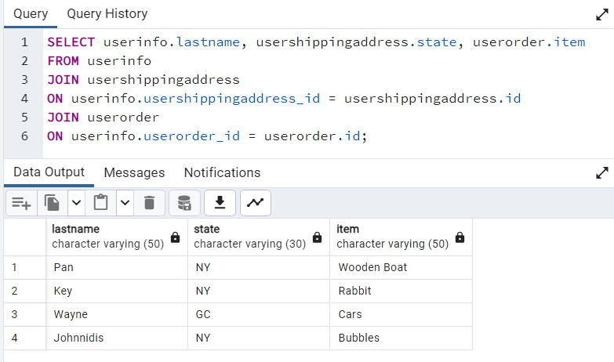

**Firstname, address, zipcode, quantity, items and totalprice**

